Thought Log

Tracking your thinking as you read
- I used to think__________________, but now I think________. This happened because…
- I still think _____________, but I’d like to add __________. It would be better because…
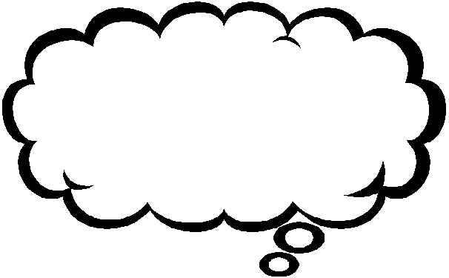
- Others think ____________, but I think ____________ because...

Thought starters
Make sure you complete one entry per night.

Each entry should be a minimum of three sentences.

Make sure to include specific details from the book so we can clearly understand your thoughts.
I noticed…
I wonder…
I was reminded of…
I think…
I’m surprised that…
I’d like to know…
I realized…
If I were…
The central issue(s) is (are)...
One consequence of _______could be…
If__________, then…
I’m not sure…
Although it seems…

“THAT” statements
This passage make me think that…
This makes me feel that…
The author is suggesting that...

Things to track over time:
A character:
How does he/she change? What insights does the character gain?
What big ideas are being developed?
What conflict arises? What do these conflicts tell the reader?
Track your confusion:
What is confusing at the beginning of the book? Does the confusion remain or does it clear up?
What passages/sentences/words do you find confusing? Show evidence that you are wrestling with the confusion.

